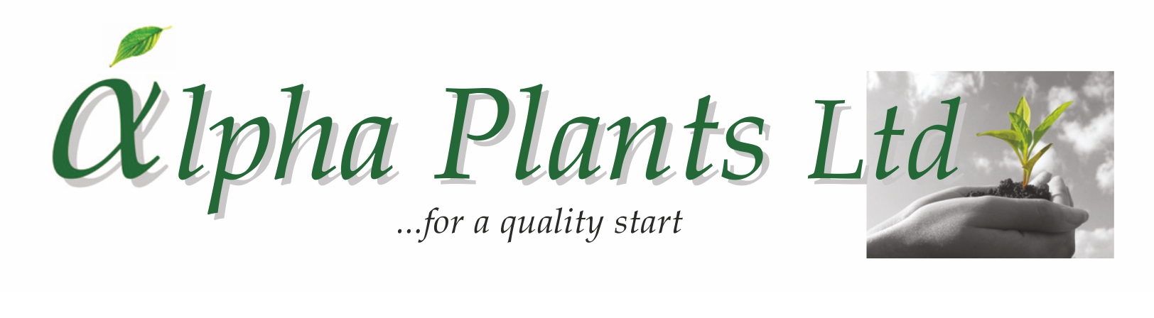
Salvia Plug Availability

for Delivery

Wks 7 to 24, 2025

Company Name………………………………………………………………………………………………………

Address…………………………………………………………………………………………………………………...

………………………………………………………………………………………………………………………………………………………………………….

………………………………………………………………………………………………………………………………..

VAT Number…………………………………………... Purchase Order Number………………………………

Contact Name …………………………………………. Phone Number …………………………………….

Email Address ……………………………………………………………………………………………………………

Delivery Address (if Different) …………………………………………………………………………………………...

………………………………………………………………………………………………………………………………..

...................................................................................................................................................................................................

How to Order:

- Complete Company name and address details together with required delivery week.

- Complete the number of trays required by variety. Sold as 84 trays. Prices are quoted ex VAT, ex nursery and do not include transport. Transport will be quoted separately where required.

- Send your order back to us either by Email: enquiries@alphaplants.co.uk or by post to
Alpha Plants Ltd, Millview Nurseries, Fengate Road, West Pinchbeck, Spalding, Lincolnshire PE11 3NE.

4) Any questions, please call us on (01775) 640150 or Email: enquiries@alphaplants.co.uk

VAT Registration Number: 367 6849 36 Plant Passport Number: GB 32470



Plant | Variety | Cell Tray Size | Price per Plant | Royalty per Plant | DELIVERY WEEK(s) ……………………………..
 |  |  |  |  | Number of Trays required:
Salvia | African Sky | 84 | 43p | 8p
Salvia | Amante | 84 | 45p | 10p
Salvia | Amethyst Lips | 84 | 43p | 8p
Salvia | Amigo | 84 | 45p | 10p
Salvia | Amistad | 84 | 45p | 8p
Salvia | Amistad Pink *NEW* | 84 | 45p | 12p
Salvia | Angel Wings | 84 | 43p | 10p
Salvia | Animo | 84 | 45p | 10p
Salvia | Apricot Spring *NEW* | 84 | 43p
Salvia x jamensis | Belle de Loire | 84 | 43p | 10p
Salvia | Berry Blast *NEW* | 84 | 45p | tbc
Salvia patens | Beyond Blue | 84 | 45p | 10p
Salvia | Black & Blue | 84 | 45p
Salvia | Blackberry Ripple *NEW* | 84 | 43p | 10p
Salvia | Blue Butterflies | 84 | 45p | 10p
Salvia | Blue Merced | 84 | 45p | 6p
Salvia | Blue Monrovia | 84 | 43p
Salvia | Blue Note | 84 | 45p | 18p
Salvia x jamensis | California Sunset | 84 | 45p | 6p
Salvia | Candy Dream *NEW* | 84 | 45p | 7p
Salvia nemorosa | Caradonna | 84 | 45p
Salvia | I Cavalieri del Tau | 84 | 43p
Salvia | Cerro Potosi | 84 | 43p
Salvia | Chalk White *NEW* | 84 | 43p
Salvia | Cherry Lips | 84 | 43p | 8p
Salvia | Cherry Pie | 84 | 45p | 7p
Salvia | Christine Yeo | 84 | 43p
Salvia | Clotted Cream | 84 | 45p | 6p
Salvia | Cool Cream | 84 | 45p | 7p
Salvia | Cool Pink | 84 | 45p | 7p
Salvia | Cool Violet | 84 | 45p | 7p
Salvia | Cuello Cream Pink | 84 | 43p | 8p
Salvia | Cuello Pink | 84 | 43p | 8p
Salvia | Cuello White Pink | 84 | 43p | 8p
Salvia | Dayglow | 84 | 43p
Salvia | Dyson’s Maroon | 84 | 43p
Salvia nemorosa | East Friesland | 84 | 45p
Saliva | Embers Wish | 84 | 45p | 10p
Salvia | Emperor | 84 | 43p
Salvia x jamensis | Flammen | 84 | 43p | 15p
Salvia | Glacier | 84 | 43p
Salvia | Harvest Sunset | 84 | 45p | 6p
Salvia microphylla | Hot Lips | 84 | 43p
Salvia greggii | Icing Sugar | 84 | 45p | 8p
Salvia | Javier | 84 | 43p
Salvia | Jemima’s Gem | 84 | 45p | 8p
Salvia | Jezebel | 84 | 43p
Salvia | Joy | 84 | 45p | 8p
Salvia | Kisses & Wishes | 84 | 45p | 10p
Salvia | Krystle Pink | 84 | 43p
Salvia | La Mancha | 84 | 43p


Plant | Variety | Cell Tray Size | Price per Plant | Royalty per Plant | DELIVERY WEEK(s) …………………...…………….
 |  |  |  |  | Number of Trays required:
Salvia | Lalarsha | 84 | 45p | 7p
Salvia | Lara | 84 | 45p | 7p
Salvia | Lemon Light | 84 | 45p
Salvia | Lipstick | 84 | 45p | 8p
Salvia | Love Hearts *NEW* | 84 | 45p | tbc
Salvia | Love & Wishes | 84 | 45p | 10p
Salvia x jamensis | Melen | 84 | 43p | 15p
Salvia | Moonlight Serenade | 84 | 45p | 6p
Salvia | Mulberry Jam | 84 | 43p
Salvia x jamensis | Nachtvlinder | 84 | 43p
Salvia | Naomy Tree | 84 | 43p
Salvia | Naturally Fuchsia *NEW* | 84 | 43p
Salvia | Neon | 84 | 45p | 7p
Salvia | Nuchi | 84 | 43p
Salvia | Oriental Dove *NEW* | 84 | 45p | 8p
Salvia | Peach Cobbler | 84 | 43p
Salvia | Peach Melba *NEW* | 84 | 45p | tbc
Salvia | Peach Parfait | 84 | 45p | 6p
Salvia x jamensis | Peter Vidgeon | 84 | 43p
Salvia | Phyllis’ Fancy | 84 | 43p
Salvia | Pink Mulberry | 84 | 43p | 10p
Salvia | Pink Pong | 84 | 45p | 8p
Salvia | Pinkish Red *NEW* | 84 | 43p
Salvia x jamensis | Pluenn | 84 | 43p | 15p
Salvia | Raspberry Melba *NEW* | 84 | 45p | tbc
Salvia | Red Salmon *NEW* | 84 | 43p
Salvia | Regal Lilac *NEW* | 84 | 45p | 10p
Salvia | Regal Rose *NEW* | 84 | 45p | 10p
Salvia | Regal Salmon *NEW* | 84 | 45p | 10p
Salvia | Royal Bumble | 84 | 43p
Salvia | Royal Velours | 84 | 43p
Salvia | Salmon Dance | 84 | 45p | 18p
Salvia x jamensis | Senorita Leah | 84 | 43p
Salvia | So Cool Pale Blue | 84 | 43p | 10p
Salvia | So Cool Purple | 84 | 43p | 10p
Salvia | Strawberries & Cream | 84 | 45p | 6p
Salvia | Strawberry Melba *NEW* | 84 | 45p | tbc
Salvia | Strawberry Split *NEW* | 84 | 45p | tbc
Salvia | Sunshine Dream *NEW* *NEW* | 84 | 45p | 7p
Salvia | Vanilla Cream *NEW* | 84 | 43p
Salvia | Violin Music | 84 | 45p | 18p
Salvia | Wendy’s Wish | 84 | 45p | 10p
Salvia | White Full Moon | 84 | 43p
Salvia | Wine & Roses | 84 | 45p | 8p

